**AN INNOVATIVE APPLICATION ON CAREER JOURNEY EDUPROGRESSOR**

POLAMURI SAHITHI1, SREESAILAM VEERA BABU2, THOTA MAHESWARI3

1 Assistant Professor, Dept of CSE, Nadimpalli Satyanarayana Raju Institute of Technology

2,3 Dept of CSE, Nadimpalli Satyanarayana Raju Institute of Technology, Visakhapatnam, 531173.

[sahithipolamuri1509@gmail.com](mailto:sahithipolamuri1509@gmail.com), [vinuvera1234@gmail.com](mailto:vinuvera1234@gmail.com), [thotamaheswari85@gmail.com](mailto:thotamaheswari85@gmail.com)

**Abstract.** In today's competitive environment, students need essential skills for opportunities, valuable career connections, and strategic career planning. Our paper proposes an innovative system, EduProgressor, to assist students in their career journey by connecting them with industry experts and facilitating network building. EduProgressor, based on "Education management, career development, and social networking," addresses critical challenges in education. It offers features like teacher-student-industry connection, real-time skill tracking, portfolio management, knowledge sharing, case studies, instant resume building, and a feedback system. EduProgressor aims to recognize student talents, provide exposure to industry experts, and help them become experts meeting industry standards.

**Keywords:** Career journey guide, industry connect, knowledge sharing resource repository.

# 1. Introduction:

In today’s modern era due to holistic conditions competition is increased in the education career system so for that career guidance, planning, industry connect, improving skills are become necessary in career journey.so we are proposing an innovative system based on integration and advancement of “Education management and career development and social networking” which was named in our paper as EduProgressor.

**1.1 Traditional Education System:**

In a traditional education system, education primarily focuses on the structured process of acquiring knowledge, skills, and values within formal institutions such as schools, colleges and universities. Key features include standardized curricular, classrooms, textbooks, examinations and academic degrees. The traditional education system often lacks a holistic view of a student's skills, experiences and career readiness. It primarily emphasizes academic achievements and doesn't necessarily prepare students for real-world challenges.

### **1.2 Traditional Education System Drawbacks:**

### Inadequate-Career-Preparation: Traditional education systems may not adequately prepare students for the practical skills and experiences required in their future careers.

### Rigid Curriculum: Traditional education often follows a one-size-fits-all approach, leaving little room for customization to individual student needs and interests.

### Lack of Practical Skills: Focus on theoretical knowledge may result in a deficiency of practical skills and real-world readiness.

### Limited Accessibility: Physical attendance in classrooms can be limiting for students with disabilities or those in remote locations.

**1.3 Traditional Career Development System:**

The traditional career development system revolves around securing employment or advancing within a chosen field. It involves job hunting, submitting resumes and attending interviews. Career development typically relies on personal connections, job boards and traditional hiring methods. It may lack resources for comprehensive skill development, networking or tracking professional achievements. Traditional systems often do not provide individuals with a complete picture of their strengths, weaknesses and career opportunities.

### **1.4 Traditional Career Development Drawbacks:**

### Overemphasis on Resumes: Traditional career development often centres on resumes and interviews, which may not provide a complete picture of an individual's capabilities.

### Limited Networking: Traditional methods of networking rely heavily on personal connections and may exclude individuals who lack such connections.

### Inefficient Job Searches: The job search process can be time-consuming and frustrating with applicants often encountering obstacles to finding suitable positions.

### Lack of Skill Development: Traditional systems may not offer resources for skill development or professional growth outside of the workplace.

### Limited Visibility: Job seekers may not have easy access to all available opportunities and employers may struggle to find suitable candidates.

### **Traditional Social Networking System:**

In the traditional social networking context, people connect and communicate through in-person meetings, phone calls or email. Building professional or personal networks often depends on physical proximity and personal introductions. Traditional systems do not leverage digital platforms to facilitate connections, collaboration and knowledge-sharing. They are limited in their ability to help individuals expand their social and professional circles beyond immediate geographic boundaries.

**1.6 Traditional Social Networking System Drawbacks:**

1. Geographic Limitations: Traditional social networks often depend on physical proximity, making it challenging to connect with individuals outside one's immediate area.
2. Lack of Professional Focus: Traditional social networks primarily serve personal connections and may not provide a dedicated space for professional networking and collaboration.
3. Limited Knowledge Sharing: Traditional systems do not leverage digital platforms for efficient knowledge-sharing and collaboration, especially on a global scale.
4. Privacy Concerns: Sharing personal information and content on traditional networks can raise privacy and security concerns.
5. Networking Inefficiencies: Traditional methods may not facilitate efficient networking and introductions, resulting in missed opportunities.

# 2. Related work:

Adrián Schroeder Esquivel Guemes proposed interactions between college students and professors in a virtual learning environment using the UADY Virtual learning management system since 2003. The study emphasizes the need for increased student motivation within the Moodle-based system, recognizing the impact of Web 2.0 and virtual learning environments on communication, collaboration, and information exchange in education [1].John Hoover conducted a comparative study on online interaction among students and faculty, highlighting a global digital divide and recommending improved infrastructure and technology use in education for both Eastern European and U.S. institutions [2].Branko Žitkoa defines student engagement across behavioural, emotional, and cognitive dimensions in e-Learning platforms. The study uses learning analytics and introduces tailored tracking variables (VTL and VTK) to enhance understanding of student engagement and knowledge acquisition [3].

Gattu Ramya designed an Android application for faculty-student interaction, streamlining tasks and fostering improved student connections through a unique inquiry system [4].Serdal TERZİ discusses teacher-student interactions in distance learning, emphasizing real-time feedback, communication tools, and cognitive and affective support through online data [5].Laura Salmi proposes practical solutions for quality interaction in online education, emphasizing an active online presence by instructors and effective communication platforms [6].Chris R. Glass explores the impact of student-faculty interactions on international students' sense of belonging, revealing varying experiences based on financial resources and academic preparedness [7].Youru Xie establishes a refined model for teacher-student interaction in online learning spaces, resulting in significant improvements in student engagement and problem-solving ability [8].Rehman Shafique discusses the transformative role of artificial intelligence in online education, focusing on machine learning and deep learning techniques [9].Sarath Tomy introduces the Map My Career model, enhancing student satisfaction through a career-focused software application [10].Manar Qamhieh presents PCRS, a personalized career-path recommender system for engineering students, catering to the Palestinian community and developing nations [11].Saeed Ashrafi presents Career-gAIde, an AI-based framework for large-scale rapid work-skill re-education, achieving precision and recall for job recommendations and required skills [12].Fadel Shaito provides an overview of career development, culminating in a career management model with recommendations for organizations and employees [13].Cohen evaluates career planning programs, emphasizing the importance of aligning with organizational goals [14].Dr. Radhika Kapur highlights vital components of successful career guidance and student counselling, acknowledging the pivotal roles of expert career counselors and individuals [15].

**3. Implementation study:**

An Innovative Application on Career Journey EduProgressor has the following modules:

**3.1 Modules**

In EduProgressor, administrators manage departments, faculty, and students, overseeing the educational structure, monitoring progress, and organizing events. They provide feedback to students on certifications, projects, internships, and achievements. Students create profiles, adding academic records, certifications, projects, and achievements. They can quickly generate resumes, participate in events, and assess their rankings. Faculty members create profiles, share expertise, post lectures, interact with students, and host career development events. They actively participate in the social networking aspect. Employees engage in events, offer job opportunities, access feedback data, and connect with candidates and industry professionals, forming a comprehensive educational and career development ecosystem.

EduProgressor is a holistic ecosystem, offering educational resources and tools for career development. It encourages collaboration through forums and networking, introduces healthy competition via challenges, and prioritizes improvement with personalized feedback and adaptive learning paths. As students engage, they acquire knowledge and skills, becoming part of a supportive community. EduProgressor is a valuable companion in their educational and professional journey.

**4. Methodology:**

# EduProgressor: Empowering Student Career Journeys

# EduProgressor's methodology is agile and systematic, starting with a comprehensive analysis of stakeholder requirements. Prototyping prioritizes user-friendly interfaces, and a robust technology stack is chosen for scalability and security. The iterative development cycle progressively integrates features, with ongoing testing and user feedback driving continuous improvement. Security measures, beta testing, and production deployment precede ongoing monitoring and updates, ensuring EduProgressor's adaptability to emerging trends and evolving user needs. The project, EduProgressor, commences by allowing students to register on the platform using their college-issue credentials. These credentials typically include details such as their name, branch, roll number, section and a link to their LinkedIn profile. During the registration process, EduProgressor enhances security by sending a one-time password (OTP) via email to verify and complete the registration, ensuring the authenticity of user accounts.

### Upon successful registration, students have the opportunity to craft comprehensive and informative profiles on EduProgressor. These profiles act as on online portfolio where students can showcase their academic and extracurricular achievements, skills and qualifications. With in the student profiles on EduProgressor, users can furnish in-depth information regarding their certifications, projects, internships and achievements. For certifications, students input specific details such as the completion date, certification title, platform and a succinct summary of what they learned. Additionally, they can attach digital copies of their certificates for validation. Concerning projects, students provide details like the project name, domain, an overview of the existing system and a description of their contributions. Furthermore, students can link project explanation videos via Google Drive. Internship records encompass information about the internship ID, company name, domain, duration, stipend and a digital copy of the internship completion certificate. Achievements include the name of the achievement, its mode of attainment, category and related images. To ensure that their profiles are accurate and up-to-date, students are afforded full control over the content within their profiles on EduProgressor. They can conveniently edit, update or delete entries for certifications, projects, internships and achievements, guaranteeing that their profiles reflect their current skills and experiences accurately. The platform introduces an innovative feature by calculating and displaying rankings for students on EduProgressor. These rankings are based on a variety of factors, with particular emphasis on certifications, projects and internships. Knowing their class ranking motivates students to excel and fosters a healthy sense of competition that can prove invaluable in their future careers.

### To simplify the process of applying for jobs or internships, the platform provides an instant resume builder on EduProgressor. By filling out a form with relevant information, students can efficiently generate professional resumes suitable for job applications, further facilitating their career journeys. EduProgressor actively encourages interaction between students and faculty members by providing students with access to lectures and educational materials shared by their educators. This fosters continuous learning and knowledge exchange, enabling students to benefit from the expertise of their professors. A vital component of the platform is its ability to facilitate student involvement in career development events on EduProgressor. This includes job postings, internships, webinars and other activities relevant to career advancement, all of which are posted by faculty, administrators and industry professionals. Access to such events provides students with opportunities to explore potential career paths, gain insights and make informed decisions regarding their future. The platform actively encourages student participation by allowing them to provide feedback on events and activities on EduProgressor. Feedback notifications are sent via email to ensure that relevant parties receive and can act upon this valuable input, facilitating continuous improvement and fine-tuning of the educational experience. Students can fully exploit the networking potential of the platform on EduProgressor by connecting with faculty members, industry professionals. Networking offers students’ opportunities for mentorship opportunities, internships, and future job prospects, significantly enhancing their career prospects. To safeguard student data and protect user accounts, the system implements critical security measures. For administrators with elevated privileges, such as college directors or principals, the platform offers control over the management of departments, faculty, and events. This flexibility allows educational institutions to tailor the platform to meet their specific requirements, ensuring that it aligns with the educational goals and objectives of the institution. EduProgressor, with its innovative and holistic approach, empowers students on their academic and professional journeys, making it a valuable asset to both students and educational institutions. EduProgressor streamlines the career development process by integrating real-time skill tracking. The platform enables students to showcase their evolving skills through a dynamic portfolio management system, providing a comprehensive overview of their academic and extracurricular achievements. Additionally, EduProgressor serves as a centralized knowledge-sharing resource repository, offering a vast array of educational materials, case studies, and industry insights to enrich students' learning experiences. This multifaceted platform bridges the gap between academia and industry, fostering a seamless transition for students from the classroom to the professional world.

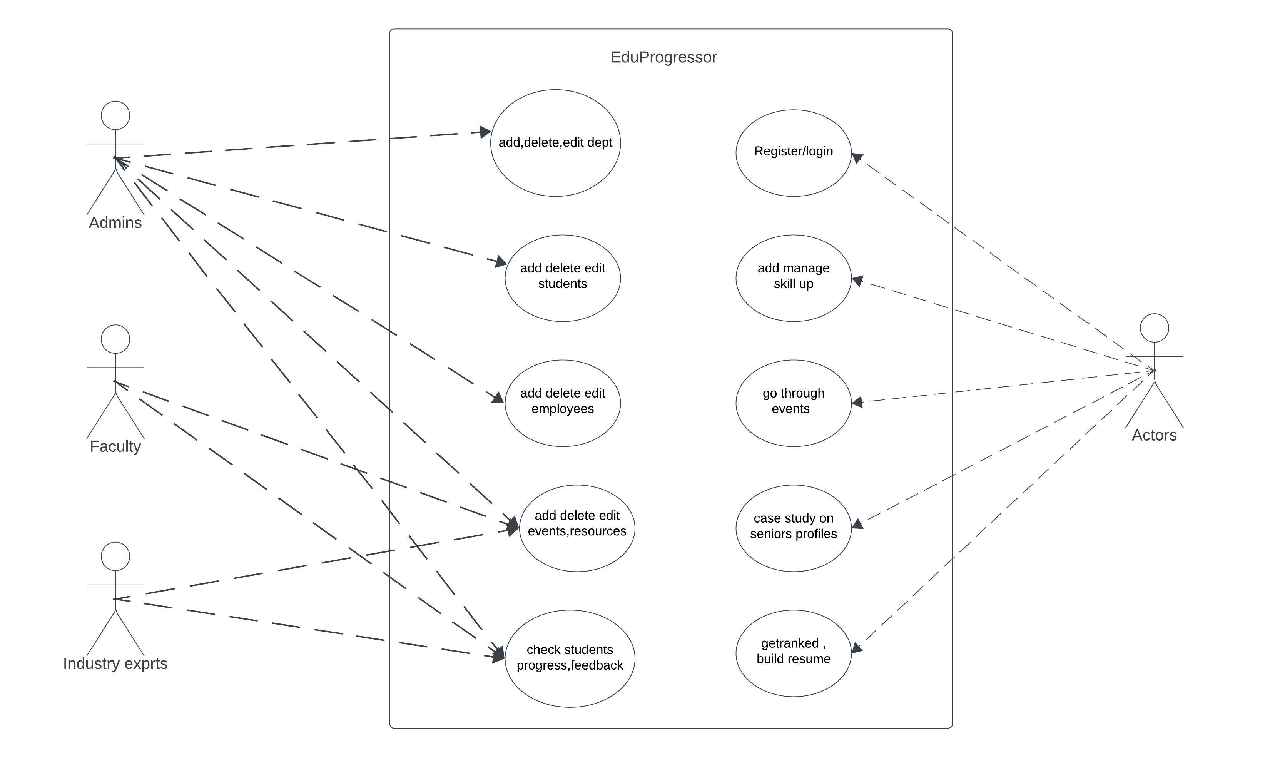

**Fig. 1.** Use Case diagram of EduProgressor.

**5. Proposed system:**

This proposed system which overcomes many problems facing in current education system, career development system, social networking system. In education management system it includes courses management, teacher-student interaction as coming to career development platform includes job postings. These systems are lack of industry contact to students, feedback mechanism on students profile by industry experts, reconiziation of students talents, professional resume building, case study on relived batches projects, internships, whole their career achievement’s in college life, lack of skill tracking, lack of awaring students about competition at around them. And no centralized platform for knowledge repository for education, career, in all aspects of student’s career journey.

So by overcoming all problems mentioned above are proposing an innovative and integrated system which combines education management, career development, social networking system and helps students in their career journey by providing teacher-student-industry contact, opportunity to connect and get guidance from industry experts to students , helps in social network building like LinkedIn with more advancements, case study on relived batches profiles by accessing to their certification’s, projects, internships they had done, achievements of them, and also connect with them. Our Comprehensive platform EduProgressor also provides centralized knowledge sharing resource repository, it also provides students certifications management, projects management, internships management, achievements management, get guidance from their college, industry experts through their profiles in our EduProgressor. It also includes efficient portfolio management , real-time-skill tracking, professional resume building in easy format.it also includes many features like this which helpful in guiding students career and increase success rate of students in their career.

**6. Result:**

EduProgressor has successfully addressed the needs of administrators, students, faculty and employees by offering a comprehensive platform that integrates elements of an Education Management System, Career Development System and Social Networking System. Administrators can efficiently manage the educational structure, monitor student progress and provide valuable feedback. Students can create detailed profiles, access resources and assess their own performance. Faculty members play a key role in sharing expertise, hosting events and employees can engage in recruitment and networking. The platform's unique features, including real-time feedback, rankings and a professional social network, have enhanced the educational and career development experience for all users.

**6.1 Existing System**

EduProgressor addresses the limitations of traditional education by integrating education management, career development, and social networking, providing a more comprehensive approach to student development. The platform revolutionizes career development through real-time skill tracking, industry expert connections, and dynamic portfolios, ensuring students are well-prepared for the competitive job market with a modernized approach. In response to the constraints of traditional social networking, EduProgressor leverages digital platforms to enable global connections, collaboration, and knowledge-sharing, aligning with the contemporary demands of an interconnected world. By fostering a dynamic feedback system and facilitating meaningful connections, EduProgressor enhances the overall educational experience, bridging the gap between formal education and the evolving needs of the professional landscape.

**6.2 Output/result:**

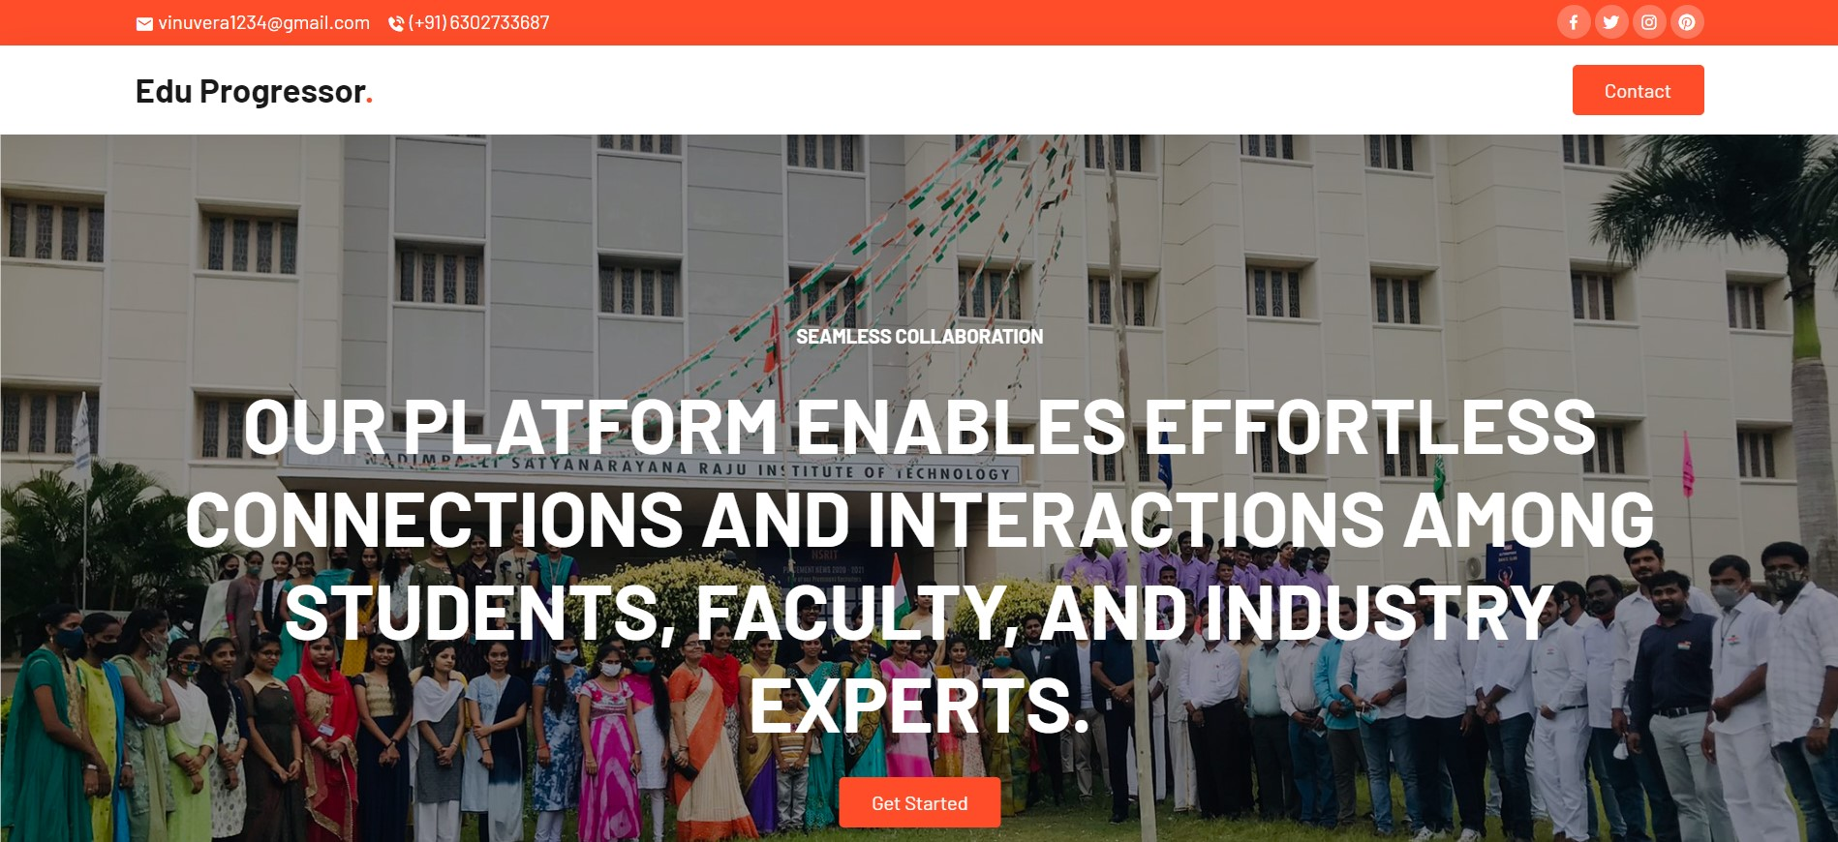

**Fig. 2.** Commencement page.

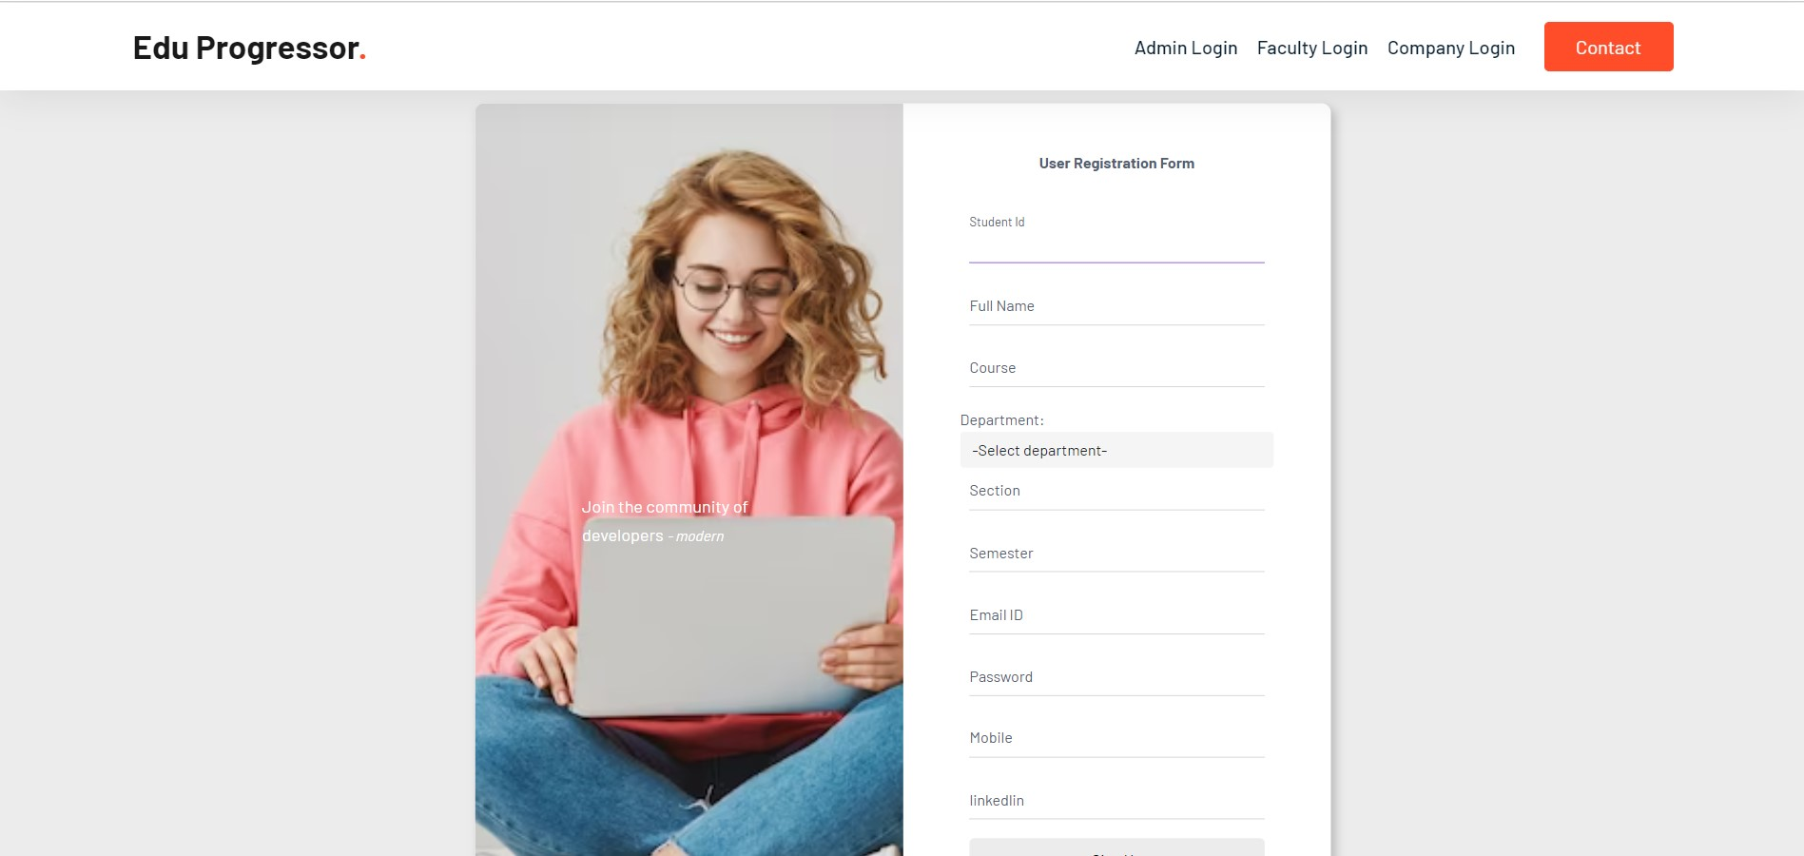

**Fig. 3.** Student Registration Page.

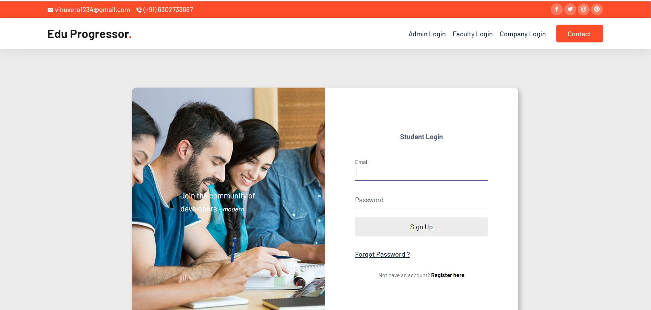

**Fig. 4.** Student Login page with login credentials, otp option also.

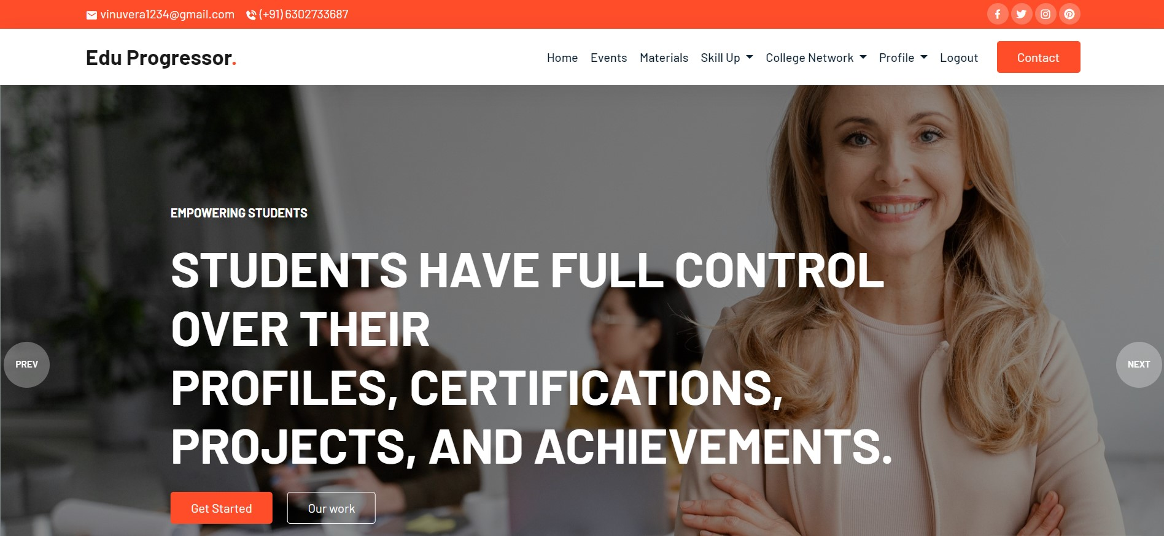

**Fig. 5.** Use home page after login.

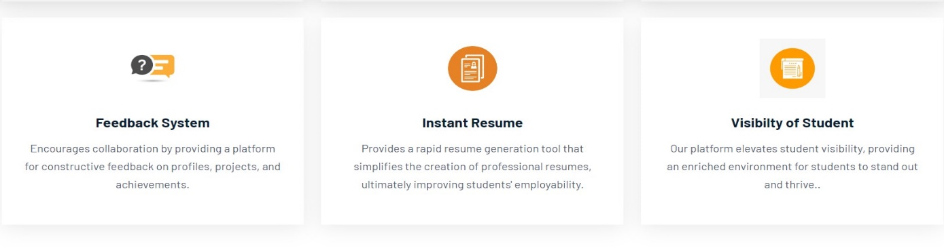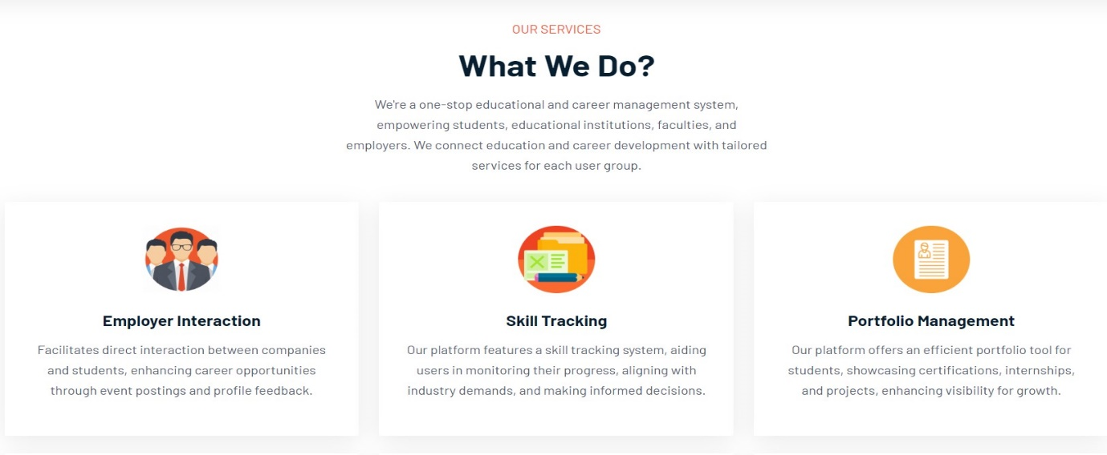

**Fig. 6.** EduProgressor main services.

# 7. Conclusion:

EduProgressor has effectively overcome the limitations of traditional education management, career development and social networking systems by providing a holistic and flexible platform. It encourages collaboration, mentorship and networking while addressing the individual needs of administrators, students, faculty and employees. The system's adaptability, real-time feedback, focus on practical skills and achievements have contributed to a more comprehensive and user-friendly approach to education and career development. EduProgressor stands as a promising solution for institutions looking to enhance the educational experience and career readiness of their students while fostering strong connections between academia and industry.

**8. Future work:**

* Implement features for industry-driven projects to bridge the gap between academia and real-world demands.
* Develop AI-driven algorithms for dynamic skill tracking, offering personalized insights.
* Incorporate real-time feedback mechanisms to help students adapt to evolving industry requirements.
* Extend social networking capabilities to facilitate international collaboration and exposure.
* Integrate language translation features for seamless communication in a global context.
* To motivate student engagement in skill-building activities.
* Create a rewards system to recognize and encourage continuous skill enhancement.
* Implement robust analytics tools to measure the platform's impact on students' career development.
* Provide detailed reports for educators and administrators to assess the effectiveness of EduProgressor.

**References:**

# 

1. Adrián Schroeder Esquivel Guemes, Pedro José Canto Herrera, Alfredo Zapata González, Víctor Hugo Menéndez Domínguez., “Interactions between College Students and Professors in a Virtual Learning Environment” IOSR Journal of Research & Method in Education (IOSR-JRME), 2018.

2. Plamen Miltenoff, John Hoover, Galin Tzokov.,“Online Interaction among Students and Faculty: A Comparative Study” Proceedings of the Informing Science & IT Education Conference (In SITE) 2008.

3. Branko Žitkoa, Slavomir Stankov, Ines Šarić-Grgić, Angelina Gašpar., “A common model for tracking student learning and knowledge acquisition in different e-Learning platforms”, journal of E-Learning Knowledge Societ, 2020.

4. Gattu Ramya, Dr. Sudhagar Govinda Swamy.,“Interaction Between Faculty And Students Through Online”, Siddhartha Institute of Technology and Sciences, 2019.

5. Serdal TERZİ, Abdurrahman ÇELİK., “Teacher-Student Interactions in Distance Learning”, The Turkish Online Journal of Educational Technology – TOJET, 2005.

6. Laura Salmi, “Student Experiences on Interaction in An Online Learning Environment as Part of a Blended Learning Implementation: What is Essentials?”, IADIS International Conference e-Learning 2013.

7. Chris R. Glass, Elizabeth Kociolek, Rachawan Wongtrirat, R. Jason Lynch, Summer Cong, “Uneven Experiences: The Impact of Student-Faculty Interactions on International Students’ Sense of Belonging”, Journal of International Students - 2015.

8. Youru Xie, Yuling Huang, Ziru Ouyang, “Design and Effects of the teacher-student interaction model in the online learning spaces”, Journal of Computing in Higher Education – 2022.

9. Rehman Shafique, Wajdi Aljedaani, Furqan Rustam, Ernesto Lee, Arif Mehmood, Gyu Sang Choi, “Role of artificial Intelligence in Online Education: A Systematic Mapping Study”, Journal Article – 2023.

10. Sarath Tomy, Eric Pardede, “Map My Career: Career Planning Tool to Improve Student Satisfaction”, Journal Article – 2019.

11. Manar Qamhieh, Haya Sammaneh, Mona Nabil Demaidi, “PCRS: Personalized Career-Path Recommender System for Engineering Students”, Journal Article – 2020.

12. Saeed Ashrafi, Babak Majidi, Ehsan Akhtarkavan, Seyed Hossein Razavi Hajiagha, “Efficient Resume-Based Re-Education for Career Recommendation in Rapidly Evolving Job Markets”, Journal Article – 2023.

13. Fadel Shaito, “Career Development: An Overview” – 2019.

14. Cohen, Barbara S., “Career Development in Industry. A Study of Selected Programs and Recommendations for Prcgram Planning Educational Testing Service”, Princeton, N.J. PUB DATE Dec 77.

15. Dr. Radhika kapur, “Career Guidance and Student counselling”, University of delhi – 2018.